Name: Syed Mohammad kaif
Reg no: 192472278
Course Name: Design and Analysis of Algorithm
Course Code: CSA0652
Assessment: CO5-Assessment Tool 2

Report 1
Q91: N-Queens Problem with Symmetry Elimination Using Backtracking

Aim

The objective of this experiment is to solve the N-Queens Problem using the Backtracking technique while eliminating symmetric duplicate solutions. The algorithm places N queens on an N × N chessboard such that no two queens attack each other and generates only unique valid arrangements.

Problem Description

The N-Queens problem is a classical combinatorial optimization and constraint satisfaction problem. The goal is to place N queens on an N × N chessboard so that:

- No two queens are placed in the same row.
- No two queens are placed in the same column.
- No two queens are placed on the same diagonal.

Since many solutions are merely rotations or reflections of others, symmetry elimination is applied to avoid generating duplicate solutions and improve efficiency.

Objectives

- Implement a Backtracking algorithm to solve the N-Queens problem.
- Check column and diagonal safety constraints.
- Eliminate symmetric duplicate solutions.
- Reduce the search space using pruning techniques.
- Generate all unique valid arrangements of queens.

Algorithm

Step 1: Initialization

Create an empty chessboard represented by a one-dimensional array where the index represents the row and the value represents the column position of a queen.

Step 2: Recursive Placement

Place queens row by row.

Step 3: Safety Check

Before placing a queen, verify:

- No queen exists in the same column.
- No queen exists on either diagonal.

Step 4: Backtracking

If a safe position is found:

- Place the queen.
- Move to the next row recursively.

If no safe position exists:

- Remove the previously placed queen.
- Try another position.

Step 5: Symmetry Elimination

For every complete solution:

- Generate all possible rotations and reflections.
- Convert them into a canonical representation.
- Store only the lexicographically smallest representation.
- Discard symmetric duplicates.

Step 6: Output

Print all unique valid solutions.

Pruning Techniques Used

  - Column Pruning

If a queen already exists in a column, further exploration is stopped.

Diagonal Pruning

If a queen attacks diagonally, that branch is immediately discarded.

Symmetry Pruning

Mirror-image and rotationally equivalent solutions are removed.

First-Row Reduction

Only half of the first-row columns are explored because the remaining half produces mirror-image solutions.

These pruning methods significantly reduce computational effort.

Example Input
N = 4

Unique Solution

. Q . .
. . . Q
Q . . .
. . Q .

Output

Total Unique Solutions = 1
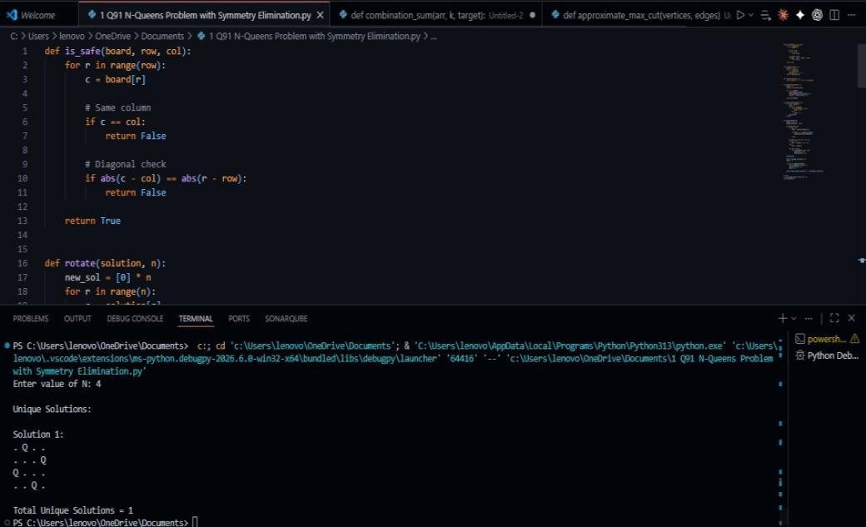

Although the standard 4-Queens problem has 2 solutions, they are mirror images of each other. After symmetry elimination, only one unique solution remains.

Correctness of the Algorithm

The algorithm guarantees correctness because:

- Every queen placement is checked for safety before being accepted.
- Backtracking systematically explores all feasible configurations.
- Invalid configurations are pruned immediately.
- Canonical representation ensures that symmetric solutions are counted only once.
- Every unique valid arrangement is eventually discovered and printed.

Therefore, the algorithm generates all and only valid unique solutions.

Complexity Analysis Time Complexity
In the worst case: O(N!)

The algorithm may explore permutations of queen placements across rows.

However, pruning and symmetry elimination considerably reduce the actual search space.

Space Complexity: O(N) Space is required for:
- Board representation
- Recursive call stack

Additional storage is used for maintaining unique solutions.

Advantages

- Produces only unique solutions.
- Eliminates redundant symmetric arrangements.
- Reduces execution time through pruning.
- Efficient for moderate values of N.
- Demonstrates the effectiveness of Backtracking in constraint satisfaction problems.

Applications

- Artificial Intelligence and Constraint Satisfaction Problems (CSP).
- Resource Allocation Systems.
- Scheduling and Planning Problems.
- Puzzle Solving Algorithms.
- Parallel Processing and Task Assignment.
- VLSI Circuit Design.

Result

The N-Queens problem was successfully solved using the Backtracking technique with symmetry elimination. The algorithm correctly generated all unique valid queen arrangements while avoiding redundant symmetric solutions. Pruning strategies effectively reduced unnecessary exploration, improving computational efficiency and demonstrating the power of Backtracking for solving combinatorial optimization problems.

